John Kiyak

Program 2

CS355

1. “Calculate the average transit time from A to P and calculate the standard deviation.

The average transit time from A to P on the first test with 10,000 cars is 14.9985 , and the standard deviation is 26.96947

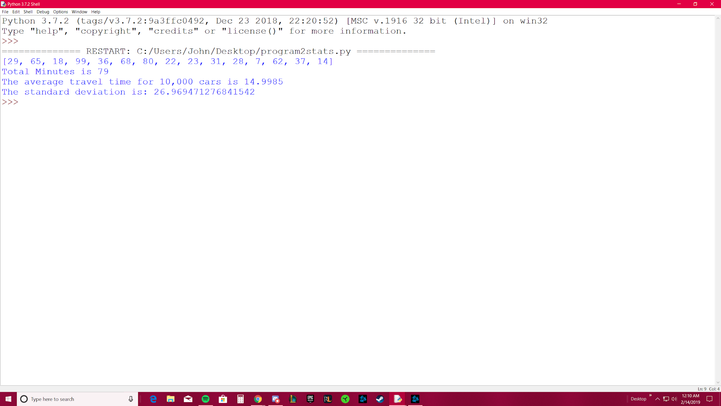

2) Run this program 10 times and compute the average transit time for 100,000 cars and the standard deviation.

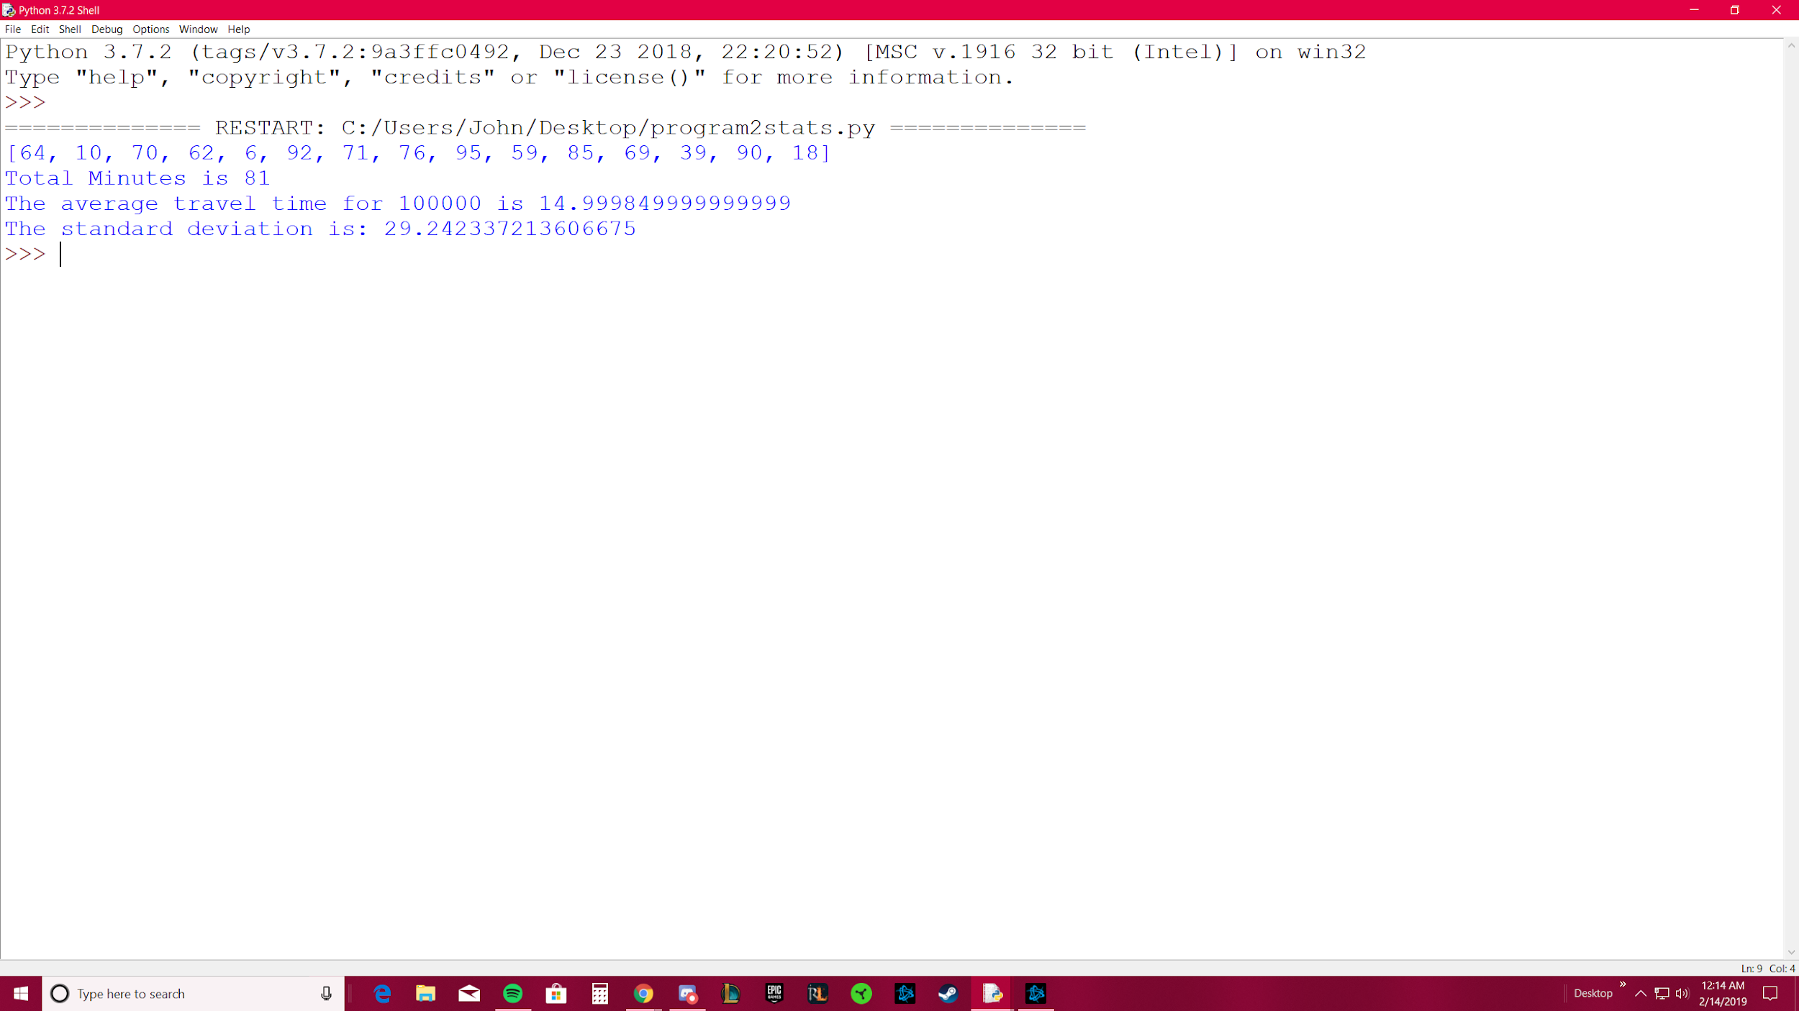

3) Compare the 10 runes of 10,000 with the one run of 100,000.

